Editor | Editorial office

HEWI
Marketing + Innovation

HEWI Heinrich Wilke GmbH
Postfach 1260
D-34442 Bad Arolsen
Telefon: +49 5691 82-0
presse@hewi.de
www.hewi.com

Reprint free – specimen copy desirable

WARM TOUCH
Innovative Material for Hospitals, Rehab and Care
WARM TOUCH combines the visual properties of high-gloss chrome surfaces with the haptic properties of polyamide. Polyamide has a pleasant temperature when touched and contributes to the sense of well-being. WARM TOUCH has been developed for use in the health sector. Due to their warm surface, WARM TOUCH products are especially suitable for patients with increased sensitivity to cold, for example, those with rheumatic diseases. The round tubular design enables symmetrical gripping.
The chrome-look coating method not only enables a high-quality chrome look to be achieved and a high degree of gripping comfort, but also an extremely resistant surface. The material is highly impact and scratch resistant. WARM TOUCH products are insensitive to UV light as well as disinfectants and cleaning agents. The smooth, non-porous surface facilitates cleaning and therefore increases hygiene.

Design: Noa, Aachen

Awards: universal design award 2013

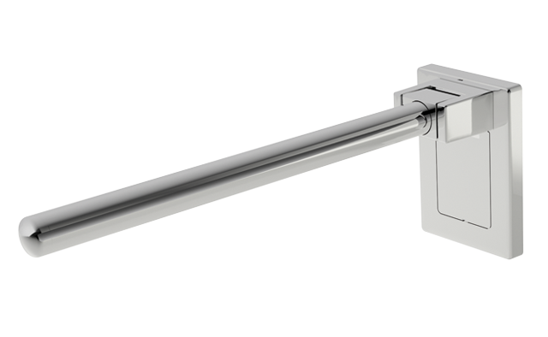

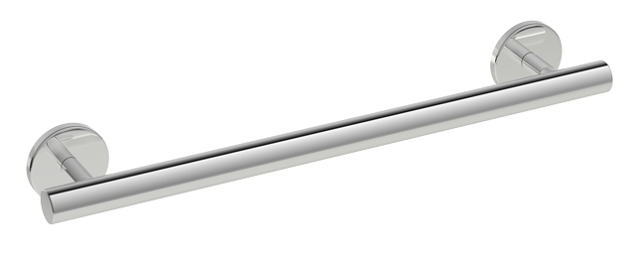

WARM TOUCH Support rail WARM TOUCH Hinged support rail Mono

Further information is available from:

HEWI Heinrich Wilke GmbH
Postfach 12 60
D-34442 Bad Arolsen
Phone +49 5691 82-0
Email: info@hewi.de
Internet: www.hewi.com

